**Semester: V Name of Student:**

**Academic Year: 2022-23 Student ID:**

**Class / Branch: TE IT**

**Subject: Advanced Devops Lab (ADL)**

**Name of Instructor:Prof. Manasi Choche**

**EXPERIMENT NO. 12**

**Aim: To create a Lambda function which will log “An Image has been added” once you add an object to a specific bucket in S3**

**Theory:**

## Creating S3 Bucket

Let us start first by creating a s3 bucket in AWS console using the steps given below −

**Step 1**

Go to Amazon services and click **S3** in storage section as highlighted in the image given below −

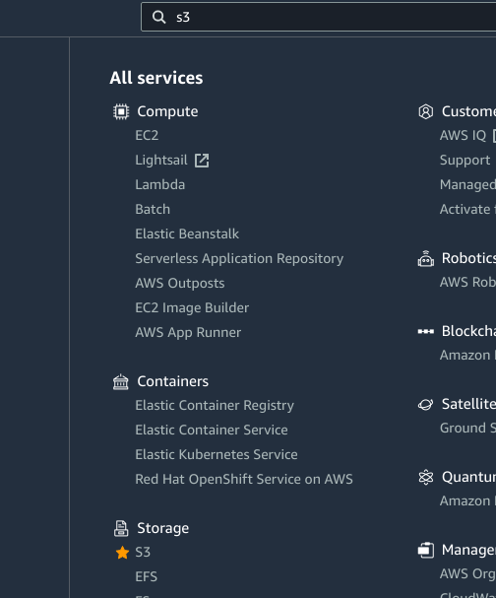

### Step 2

Click **S3** storage and **Create bucket** which will store the files uploaded.

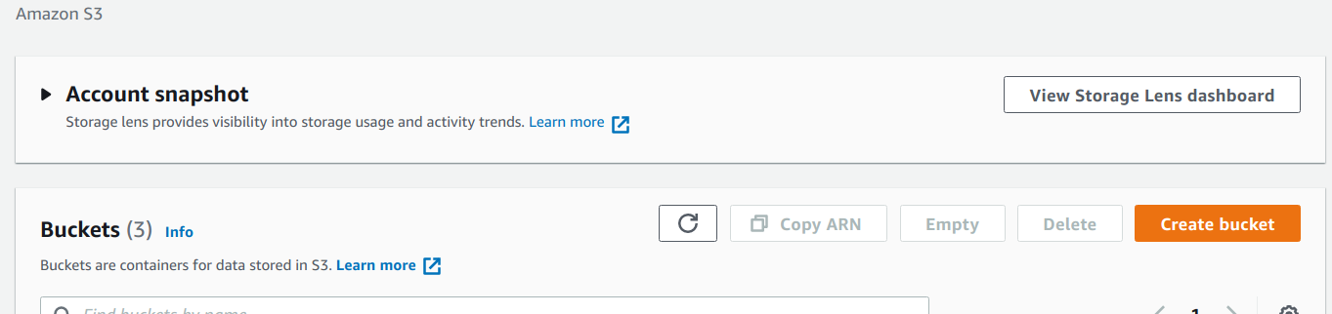

### Step 3

Once you click Create bucket button, you can see a screen as follows −

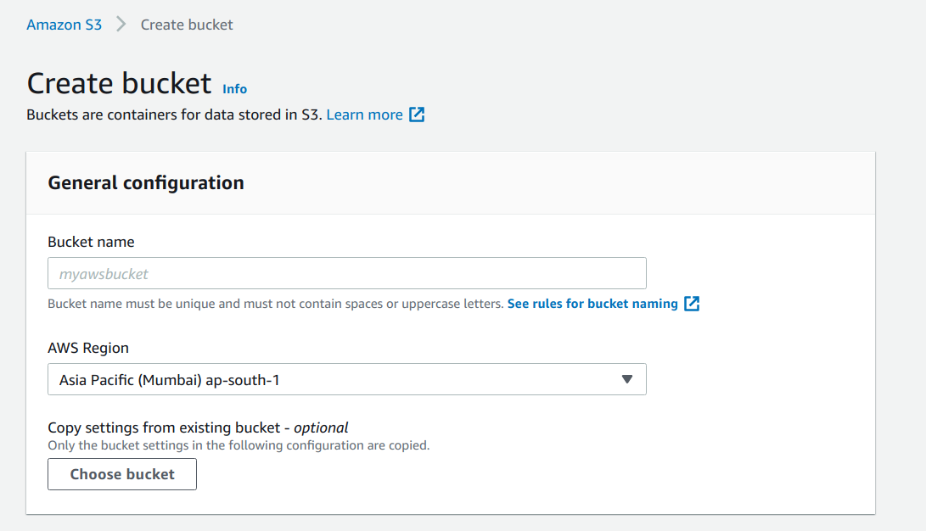

### Step 4

Enter the details Bucket name, Select the Region and click Create button at the bottom left side. Thus, we have created bucket with name :



### Step 5

Now, click the bucket name and it will ask you to upload files as shown below −

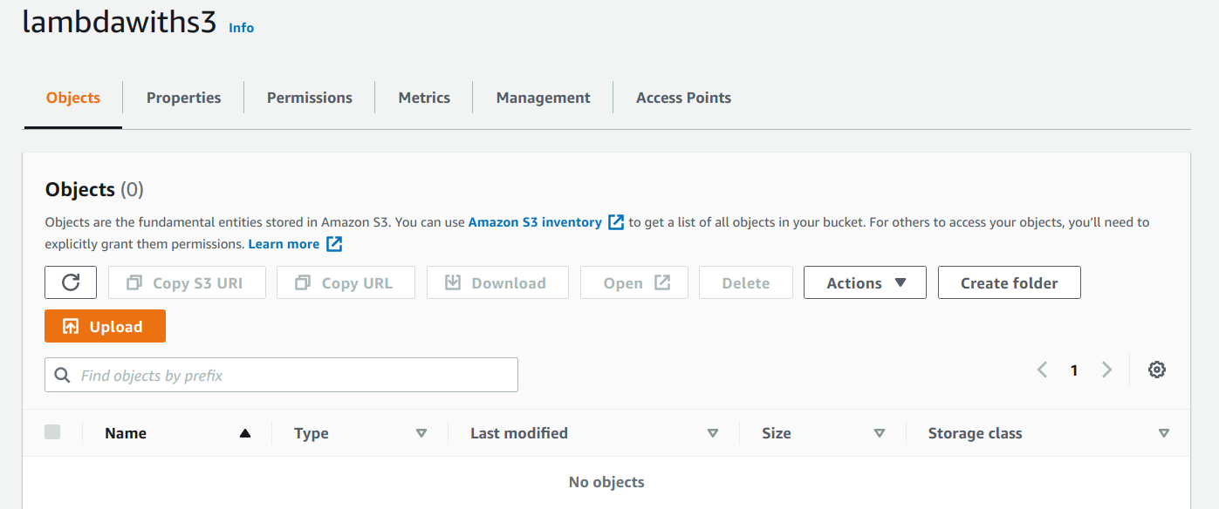

Thus, we are done with bucket creation in S3.

**Create Role that Works with S3 and Lambda**

To create role that works with S3 and Lambda, please follow the Steps given below −

### Step 1

Go to AWS services and select IAM as shown below −

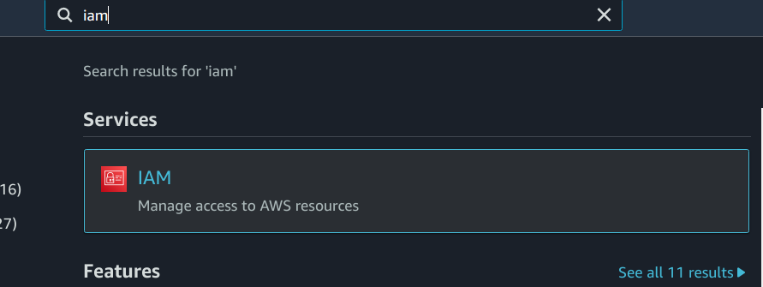

### Step 2

Now, click **IAM -> Roles** as shown below −

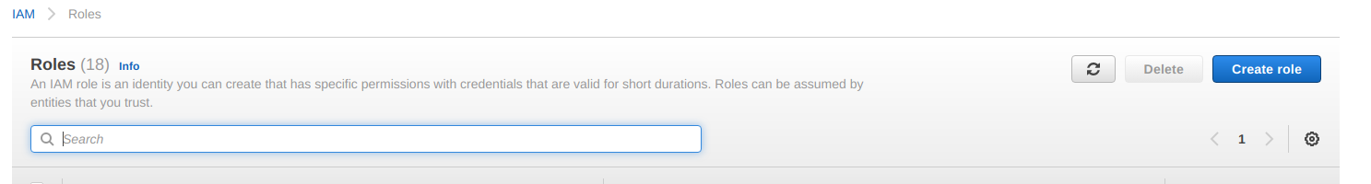

### Step 3

Now, click **Create role** and choose the services that will use this role. Select Lambda and click **Permission** button.

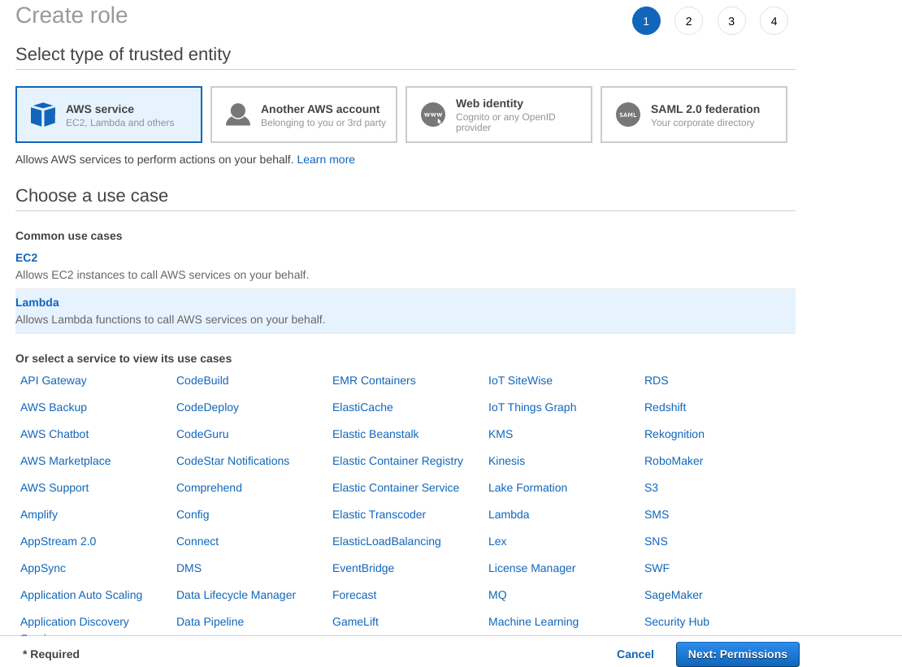

### Step 4

Add the permission from below and click Review.

**AmazonS3FullAccess, AWSLambdaFullAccess and CloudWatchFullAccess.**

### Step 5

Observe that we have chosen the following permissions −

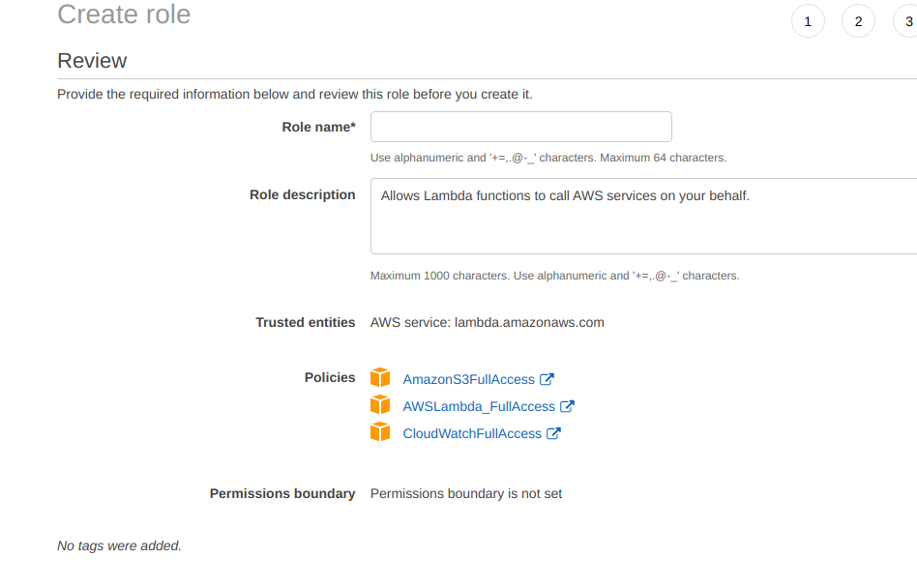

Observe that the Policies that we have selected are **AmazonS3FullAccess, AWSLambdaFullAccess and CloudWatchFullAccess.**

### Step 6

Now, enter the Role name, Role description and click Create Role button at the bottom.



Thus, our role named lambdawiths3service is created.

**Create Lambda function and Add S3 Trigger**

In this section, let us see how to create a Lambda function and add a S3 trigger to it. For this purpose, you will have to follow th Steps given below −

**Step 1**

Go to AWS Services and select Lambda as shown below −

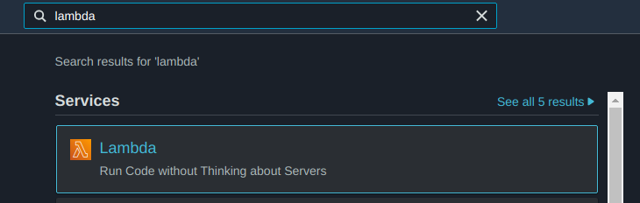

### Step 2

Click **Lambda** and follow the process for adding **Name**. Choose the **Runtime, Role** etc. and create the function. The Lambda function that we have created is shown in the screenshot below −

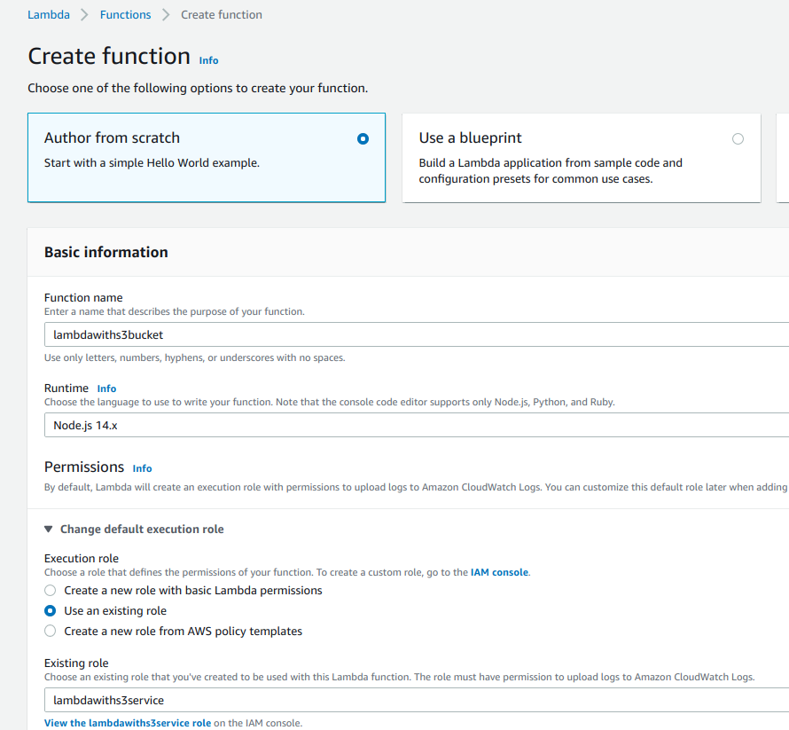

### Step 3

Now let us add the S3 trigger.

### 

### Step 4

Choose the trigger from above and add the details as shown below −

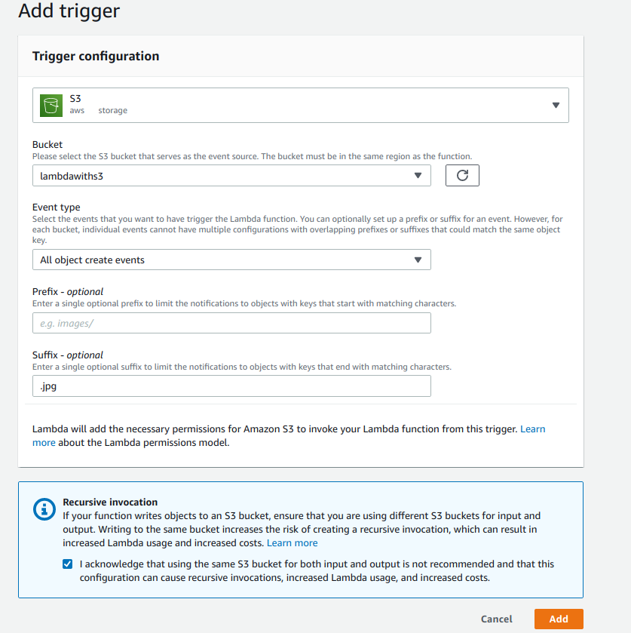

You can add Prefix and File pattern which are used to filter the files added. For Example, to trigger lambda only for .jpg images. as we need to trigger Lambda for all jpg image files uploaded. Click Add button to add the trigger.

### Step 5

You can find the the trigger display for the Lambda function as shown below −

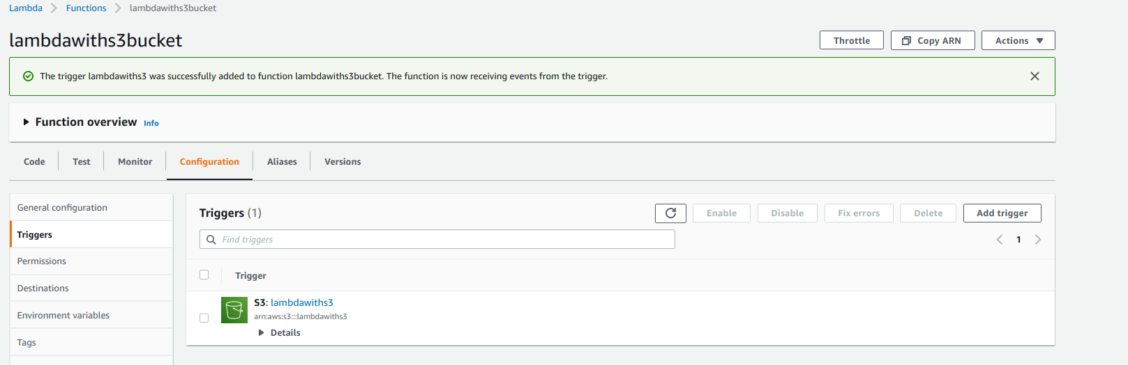

**Step 6**

Let’s add the details for the aws lambda function. Here, we will use the online editor to add our code and use nodejs as the runtime environment.

To trigger S3 with AWS Lambda, we will have to use S3 event in the code as shown below −

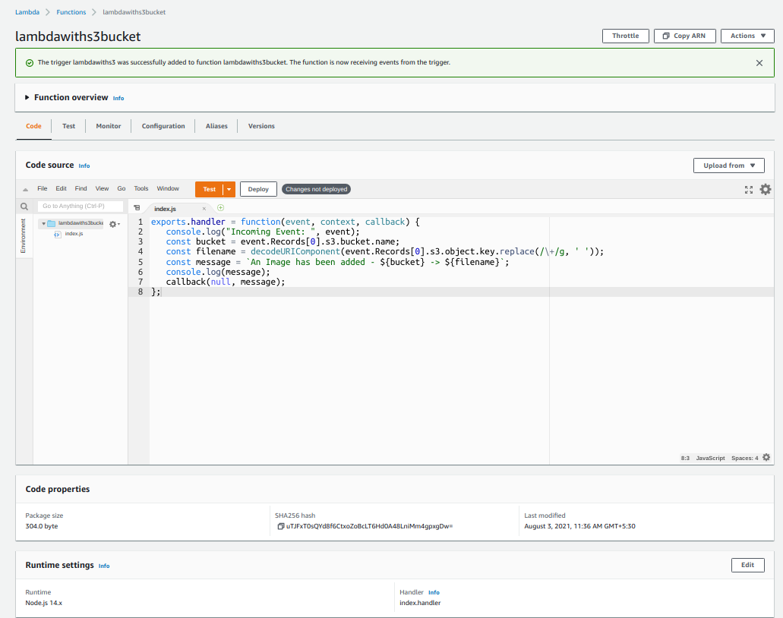

**Step 7:**

let us save the changes and test the lambda function with S3upload.

**Step 8:**

Now, save the Lambda function. Open S3 from Amazon services and open the bucket we created earlier namely lambdawiths3.

Upload the image in it as shown below −

Click **Add files** to add files. You can also drag and drop the files. Now, click **Upload** button.

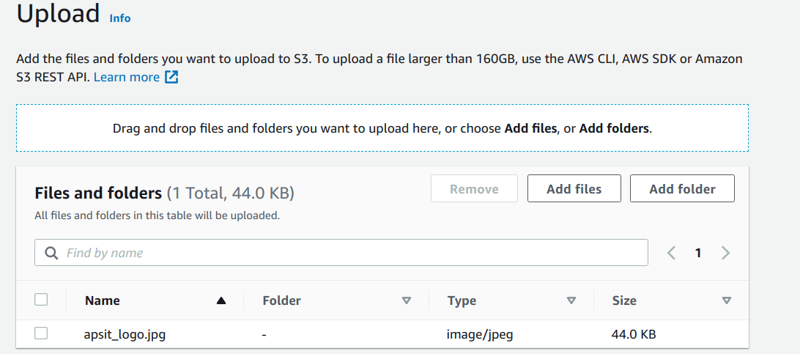

Thus, we have uploaded one image in our S3 bucket.

**Step 9**

To see the trigger details, go to AWS service and select CloudWatch. Open the logs for the Lambda

AWS Lambda function gets triggered when file is uploaded in S3 bucket and the details are logged in Cloudwatch as shown below −

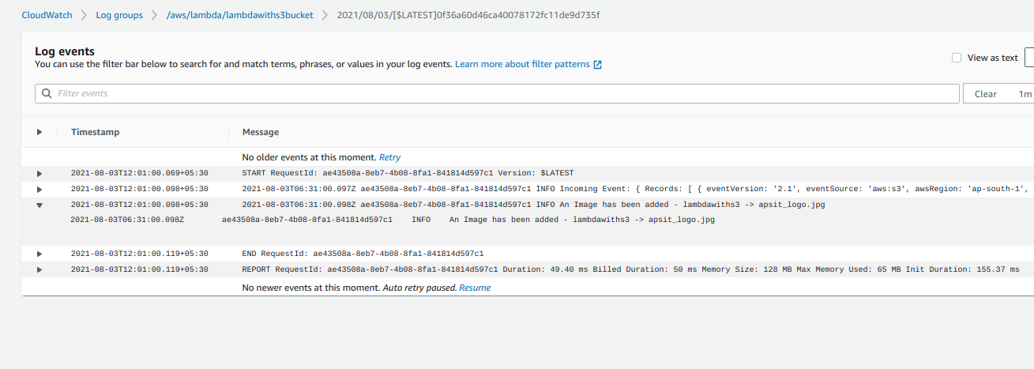

**An image has been Added -> apsit_logo.jpg** you can see in cloudwatch logs.

**Conclusion: Write your own findings.**